Provider name | West End Playgroup
URN | 521544
Declaration Form – Autumn 2021
Funded Early Education for 2, 3&4 year olds

To be completed by the child’s parent or legal guardian, for their child to claim funded early education with the provider named above, once the child has attended their first funded session.

This page may be used as authority for the provider to check in the Early Years Portal, for how many funded hours the child can have before they start attending.
Child's details - Please use legal names & block capitals.

Child Gender | Male ☐ Female ☐
Child Date of Birth
Child Legal Forenames
Child Legal Surname
Address
Postcode

hours funded childcare funding - eligibility for extended hours (if applicable)
For more information on 30 hours funded childcare, go to www.surreycc.gov.uk and search for ‘30 hours funded childcare for working parents’.

Is your child eligible for 30 hours funded childcare? | Yes ☐ No ☐  If yes, please complete the details below
Parent/legal guardian Name
Parent/legal guardian telephone number
Parent/legal guardian email address
30 hours eligibility code (e.g. 500XXXXXXXX)
Parent/guardian National Insurance Number

Parent or legal guardian agreement
- I understand that the information provided on this form will be held electronically.
- I give permission for the provider named above to search Surrey County Council’s early education portal to confirm how many funded hours my child can have, and if applicable to validate the 30 hours eligibility code.
- I agree that Surrey County Council can use my information to check my child’s eligibility for 30 hours funded childcare with the appropriate government departments (HMRC, DWP and Home Office) as allowed by law; and share the result of the check, and any change in entitlement status, with my childcare provider. I understand that my information will not be used for any other purpose, or to check eligibility for Funded Early Education for Two Year Olds, Early Years Pupil Premium or Free School Meals.

Signature of parent/legal guardian
Name (please print)
Date

You should not complete the remainder of this form until your child has attended their first funded session with the provider Provider and attendance details
Parents/legal guardians need to agree and complete a Declaration Form for each provider where their child attends for funded early education, in order to ensure that funding is paid correctly and hours are not exceeded.

Universal 15 Hours Funded Childcare
I am claiming the following number of Universal funded early education hours for my child:
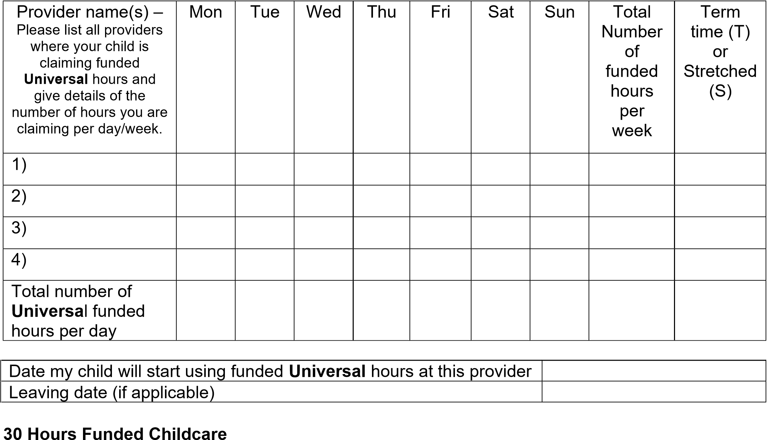
I am claiming the following number of Extended funded early education hours for my child:
Number of Extended funded early education hours attended per day
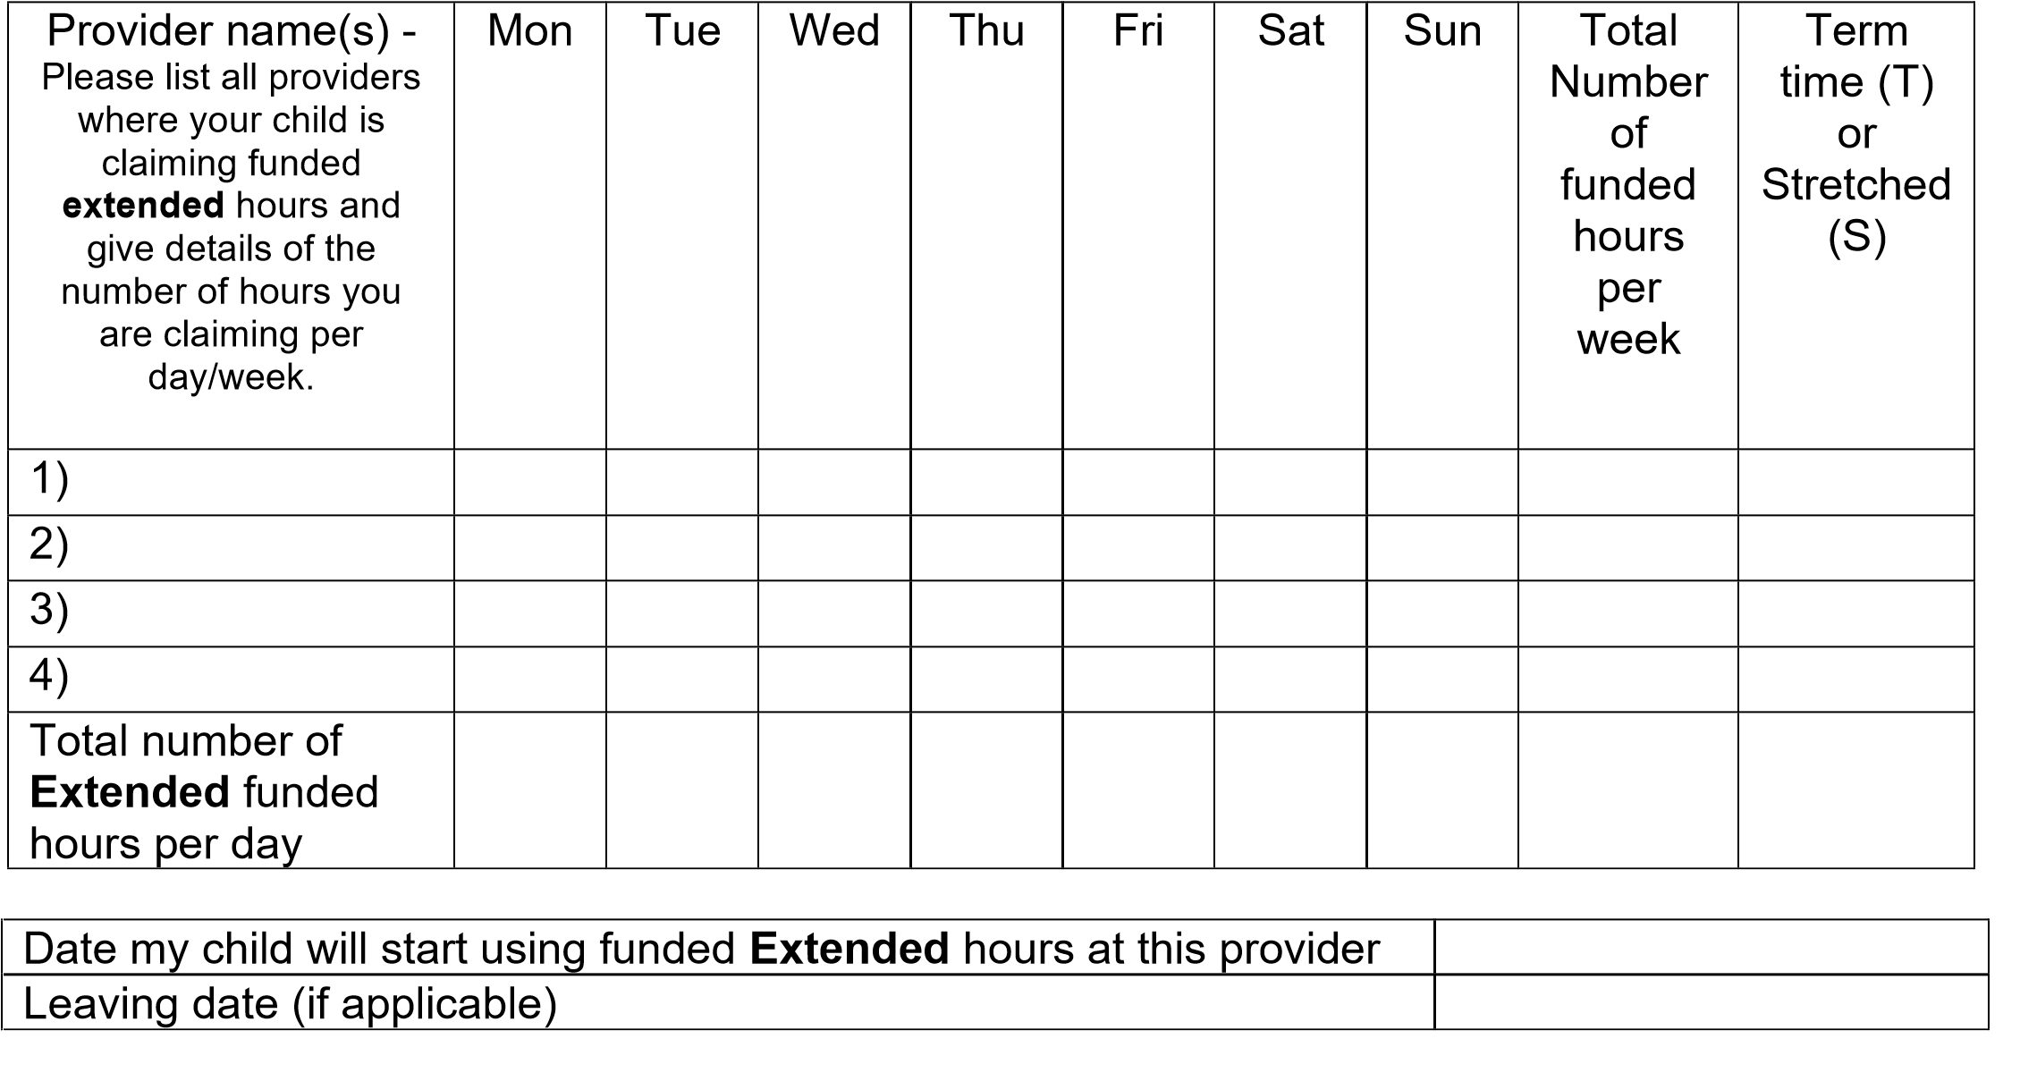
Note – The maximum number of funded hours across universal and extended is 10 per day.

Ethnicity
Only complete this section for your first funded period. We only require this information from you once.
Ethnicity – please tick the appropriate box to indicate your child’s ethnic group:
White   British   Irish   Traveller of Irish Heritage   Gypsy / Roma   Any other White background  Mixed / Dual Background   White and Black Caribbean |  White and Black African   White and Asian   Any other Mixed background  Prefer not to say   Prefer not to say  Asian or Asian British   Indian   Pakistani   Bangladeshi |  Chinese   Any other Asian background  Black or Black British   Caribbean   African   Any other Black background  Other Ethnic Group   Other ethnic group

Please tick one box only. Surrey County Council is required by the government to collect this information.

Parent or legal guardian declaration
- The details given on this form are true to the best of my knowledge.
- I will only claim funded early education for hours that my child actually attends the provider.
- I am not claiming funded early education for my child at this, or any provider, for more than my maximum hours per week.
- I have been given detailed information about the provider’s terms and conditions.
I understand that:
- My child’s details will be held electronically by Surrey County Council in order to process my claim for funded early education and will be held for six years after provision has ended.
- Information given on this form may be used to ensure accuracy of records across the local authority and to prevent and detect fraud.
- Where funded hours are shared across providers, the names and number of hours are displayed to these providers in the Early Education Portal.
- I cannot be charged for funded early education hours, and I cannot be charged for this in advance and then be refunded at a later date.
- My child’s funding will be paid directly to their provider. My child can claim universal funded early education up to a maximum of 570 hours per year as a 2, 3 or 4 year old starting from the term after their birthday, which is equivalent to 15 hours per week for 38 weeks per year (term time), or fewer hours per week for more weeks of the year (stretched). (15 or 30 hours must be claimed weekly, as the hours cannot be banked or rolled over to another week.) If I have a valid 30 hours funded childcare eligibility code, my child can attend for a maximum of 1,140 hours a year.
- If I choose stretched hours, I will not be able to change to term time hours until the term after my child’s next birthday. If I choose term time hours, I will not be able to change to stretched hours until the term after my child’s next birthday.
- If I split the hours between a childcare provider who offers term time and one who offers stretched it is unlikely that I will be able to claim the full 570 hours.
- If I move my child to a different provider, I will not be able to claim funded early education hours from the new provider during the current funded period (term), without the permission of my current provider and/or Surrey County Council, unless I gave notice before the start of the funded period.
- My child cannot use their funded early education hours at more than two sites in one day, for more than 10 hours in any one session, or for more than 14 hours a day.
- If I choose to take up any more hours or services outside of the funded early education hours, I will have to pay my provider for the hours and/or services that are not funded.
- Surrey County Council will reclaim funding if during an audit it appears, I have claimed for more funded early education hours than my child has actually attended, or I have claimed more than my maximum funded early education hours per week.
- My child’s provider can choose when in the week they offer funded early education.
- I may have to pay full fees to this provider if my child goes to a maintained school, free school or academy at any time during this funded period (term).
- I am in agreement with the Early Education Funding Privacy Notice (available at https://www.surreycc.gov.uk/council-and-democracy/your-privacy/our-privacy-notices/early-yearsentitlement-funding)
Signature of parent/legal guardian
Name (please print)
Date

Telecommunication (Lawful Business Practice) (Interception of Communications) Regulations 2000. Communication with the local authority (including online transactions) may be subject to monitoring and recording only for purposes permitted by the Telecommunication (Lawful Business Practice) (Interception of Communications) Regulations 2000 in order to prevent or detect a crime, or investigate or detect the unauthorised use of the service.

Provider use only
Type of proof of date of birth document seen
(e.g. birth certificate, passport)
Date document seen (at time of first registration)
Document seen by (name of staff member)
Signature
Date

